CSA0613 DESIGN ANALYSIS AND ALGORITHM FOR Approximation Problems
Jeya Harshini R
192424051
TOPIC 1
EXP 1: Given an array of strings, return the first palindromic string. If none exists, return an empty string.
AIM: To find and return the first palindromic string from a given array of strings.
CODE:
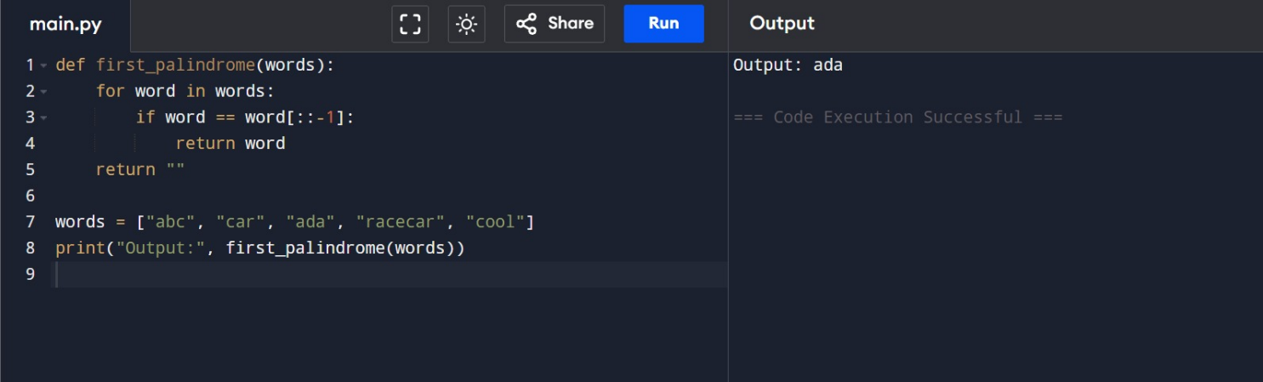
RESULT: The first palindromic string in the given array is successfully identified and returned. If no palindrome exists, an empty string is returned.
EXP 2: Count Common Elements in Two Arrays
AIM: To count how many elements of one array exist in the other array.
CODE:
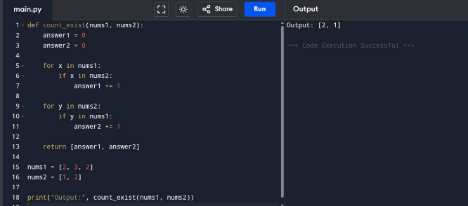
RESULT: The number of common elements in both arrays is calculated correctly.

EXP 3. Sum of Squares of Distinct Elements in All Subarrays

AIM: To compute the sum of squares of distinct element counts for all subarrays.

CODE:

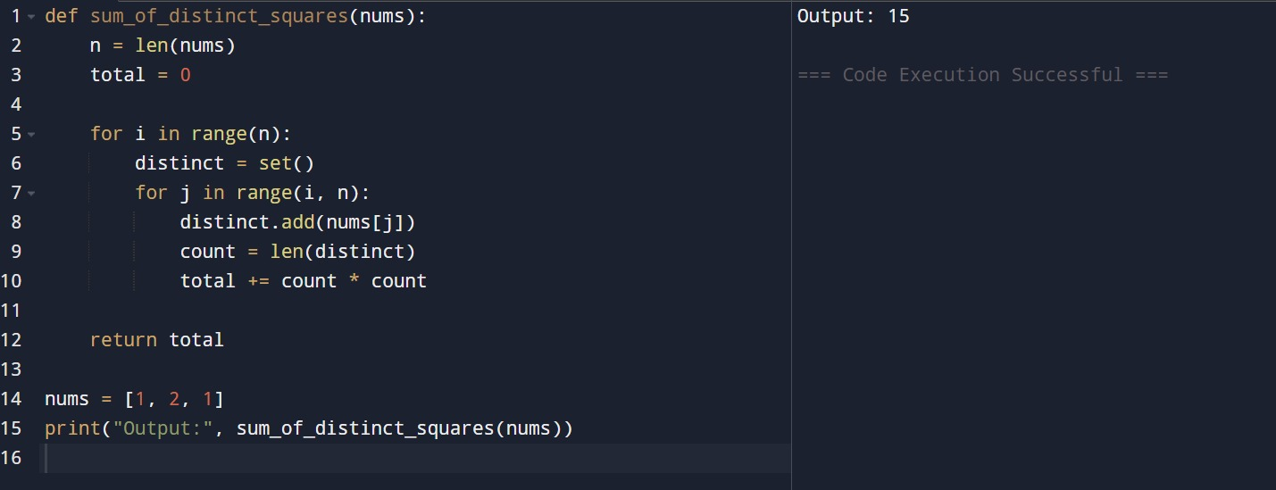

RESULT: The sum of squares of distinct counts is computed correctly.
EXP 4. Count Valid Index Pairs
AIM: To count pairs (i, j) where nums[i] = nums[j] and (i * j) is divisible by k.
CODE:
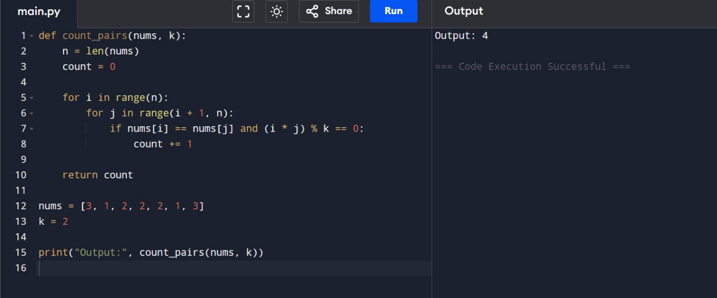
RESULT: All valid index pairs are counted successfully.

EXP 5: Program with Least Time Complexity
AIM: To find the maximum element from the given array efficiently.
CODE: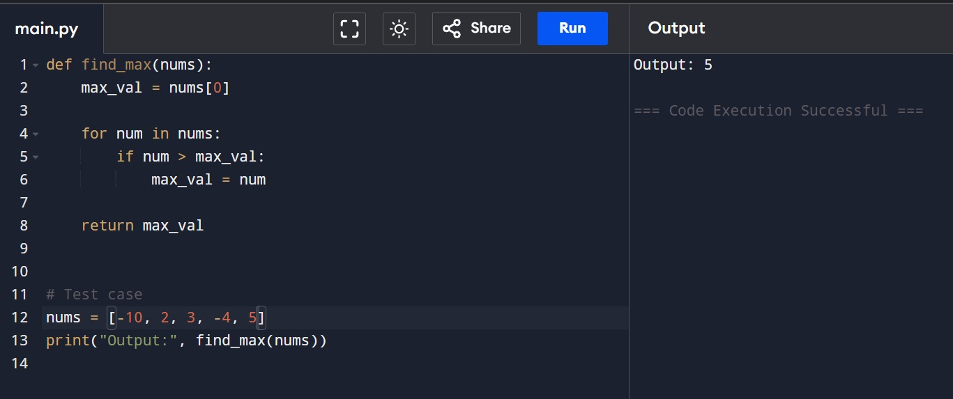
RESULT: The maximum element is found in linear time O(n).
EXP 6: Sort and Find Maximum Element
AIM: To sort a list and find the maximum element.
CODE: 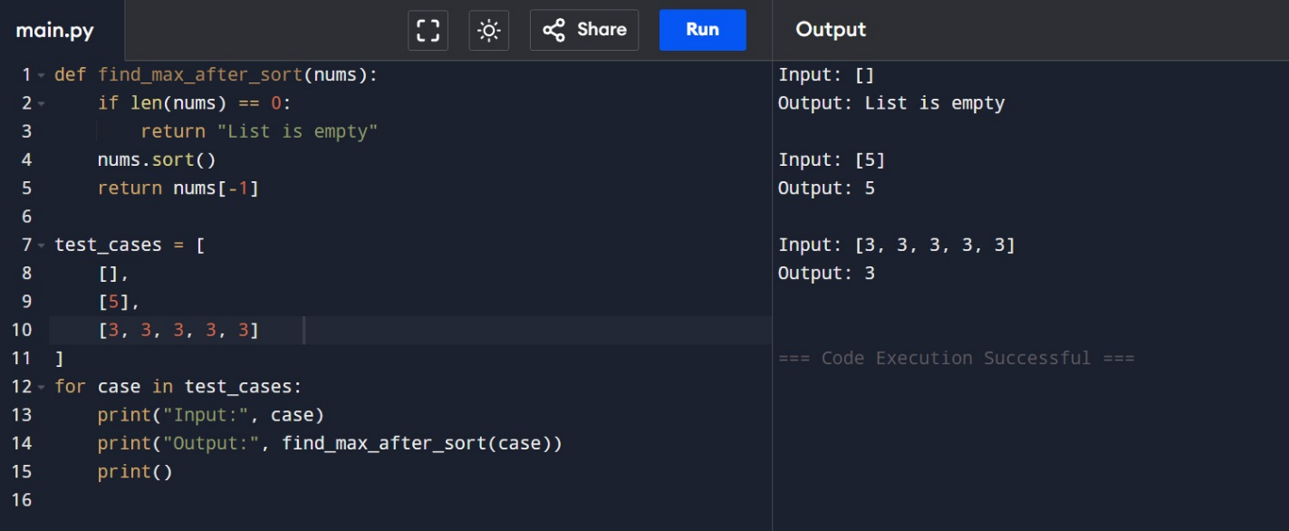
RESULT: The maximum element is correctly identified after sorting.
EXP 7: Extract Unique Elements
AIM: To create a new list containing only unique elements.
CODE:
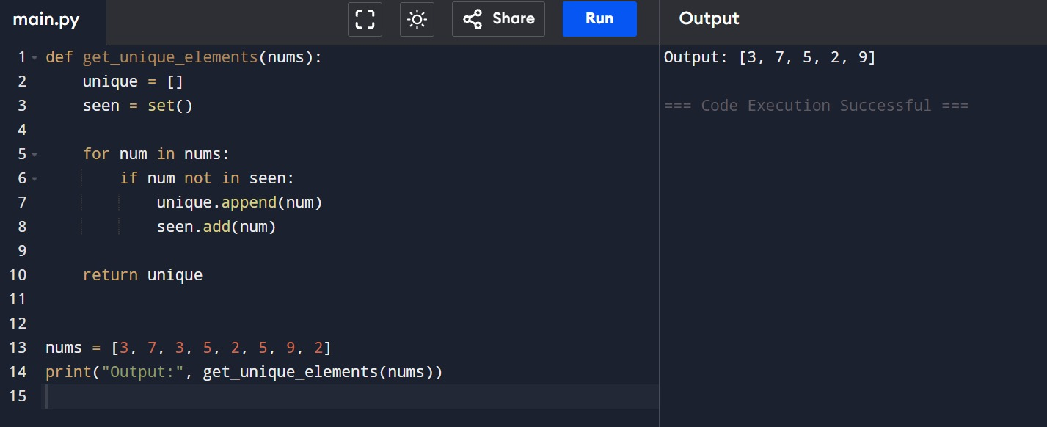
RESULT: Duplicate elements are removed successfully.
EXP 8: Bubble Sort and Time Complexity
AIM: To sort an array using Bubble Sort and analyze its time complexity.
CODE:
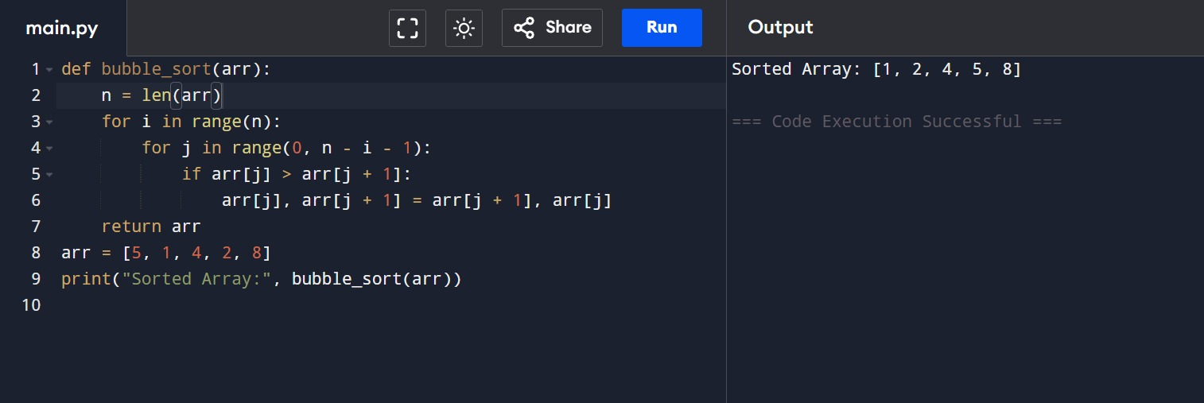
RESULT: Array is sorted correctly using Bubble Sort.
Time Complexity: O(n²)

EXP 9: Binary Search in Sorted Array
AIM: To check whether a given element exists using Binary Search.
CODE: 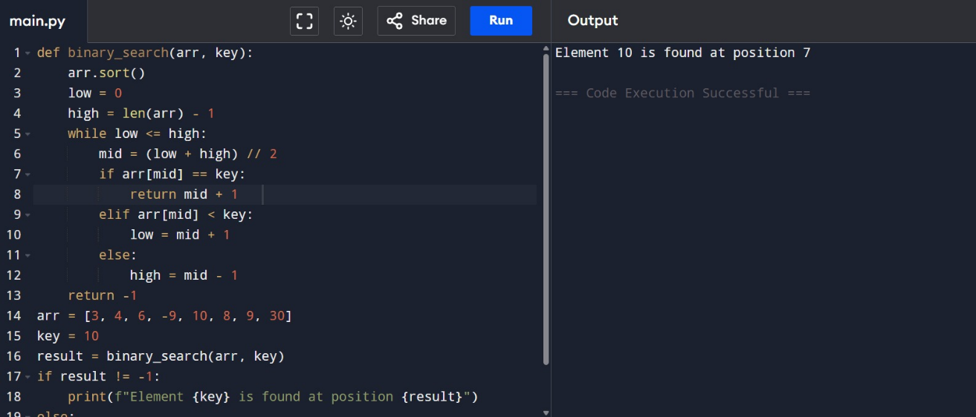
RESULT: Binary search successfully finds the element.
EXP 10: Sort Without Built-in Functions (O(n log n))
AIM: To sort an array in ascending order without using built-in functions.
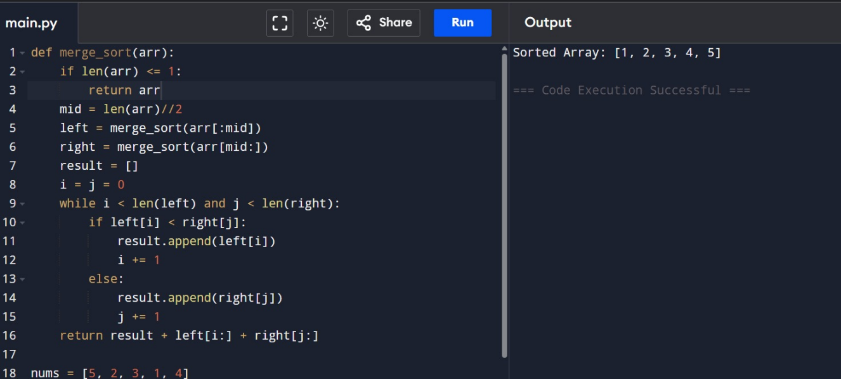
CODE:

RESULT : The array is sorted in O(n log n) time with minimal space usage.

EXP 11: Number of Ways to Move Ball Out of Grid Boundary
AIM: To find the number of ways to move a ball out of the grid boundary in exactly N steps.
CODE: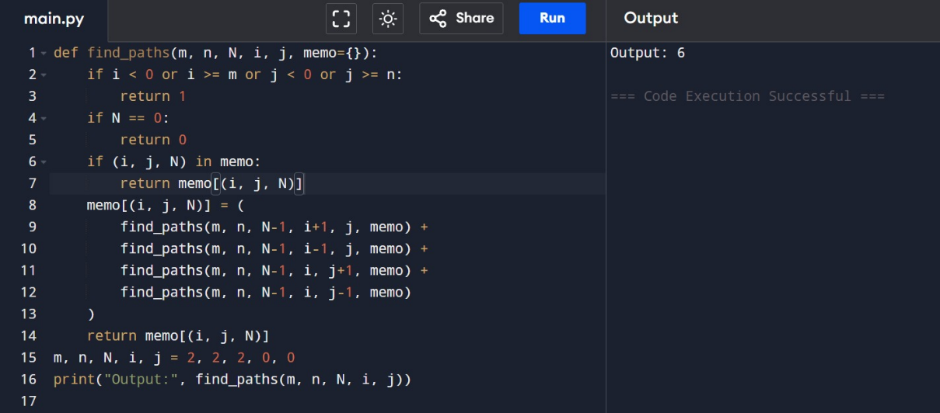
RESULT: The number of ways to move the ball out of the grid in exactly N steps is calculated correctly.
EXP 12: House Robber (Circular Houses)
AIM: To find the maximum amount of money that can be robbed without alerting the police when houses are arranged in a circle.
CODE :
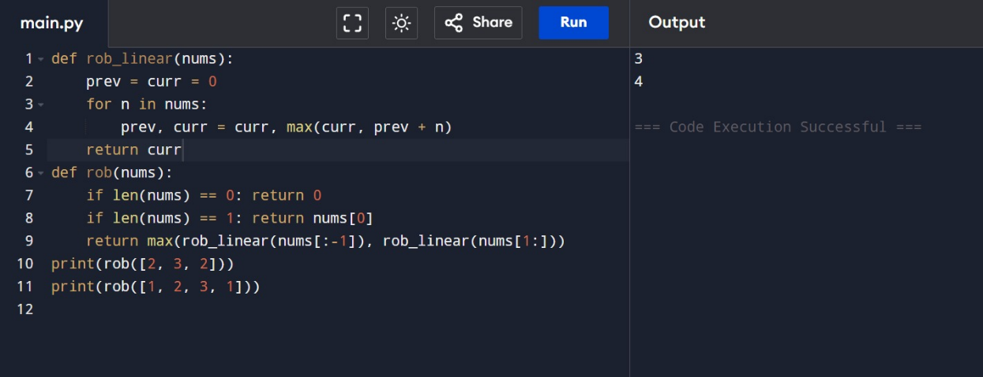
RESULT : The maximum money is obtained without triggering the alarm system.

EXP 13: Climbing Stairs Problem
AIM: To find the number of distinct ways to climb n stairs when one can take either 1 or 2 steps.
CODE:
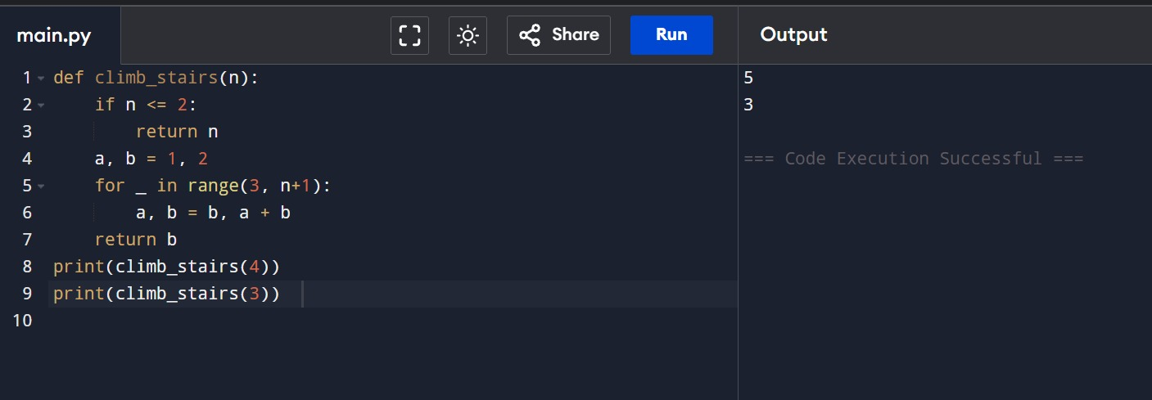
RESULT : The number of distinct ways to climb the stairs is calculated correctly.
EXP 14: Unique Paths in a Grid
AIM: To find the number of unique paths from top-left to bottom-right of a grid.
CODE:

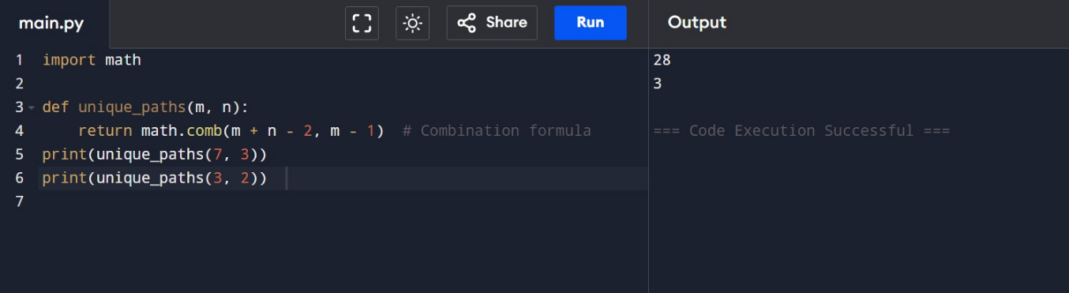
RESULT: The total number of unique paths is found successfully.

EXP 15: Large Group Positions in a String
AIM: To find all large groups (size ≥ 3) in a string and return their intervals.
CODE:
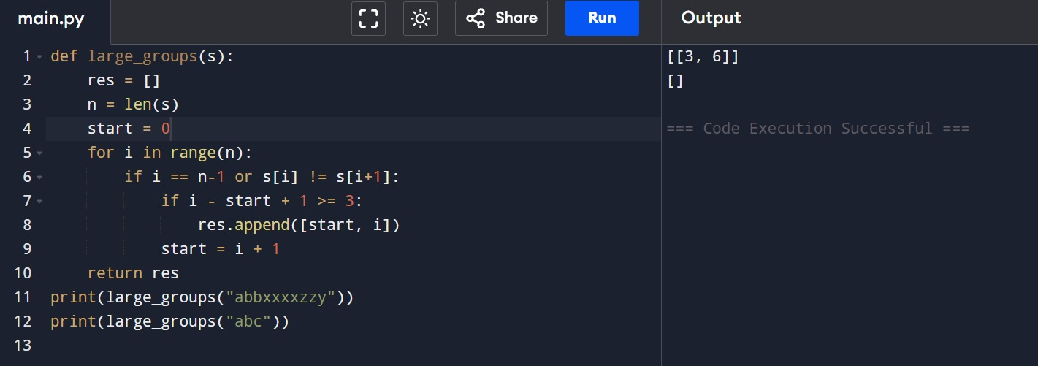
RESULT: All large character groups are identified correctly.

EXP 15: Game of Life

AIM: To simulate Conway’s Game of Life and generate the next state of an m × n grid based on given rules.

CODE:

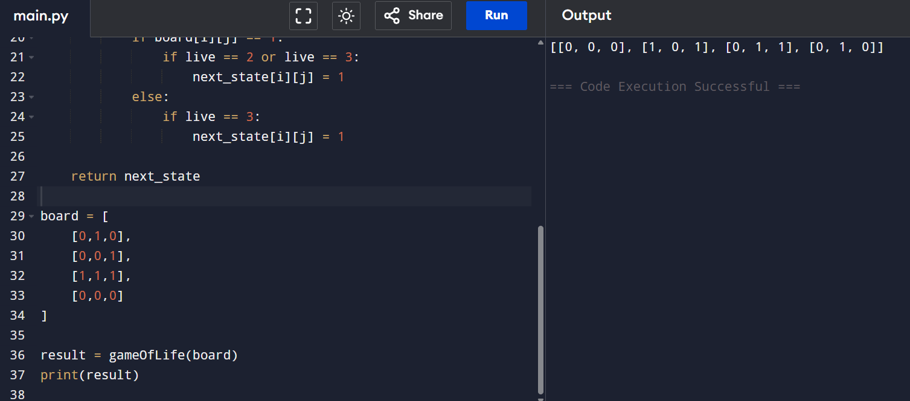

RESULT: The next generation of the Game of Life board is generated successfully by applying all rules simultaneously.

EXP 16: Champagne Tower

AIM: To determine how full a specific glass is in a champagne tower after pouring a given number of cups.

CODE:

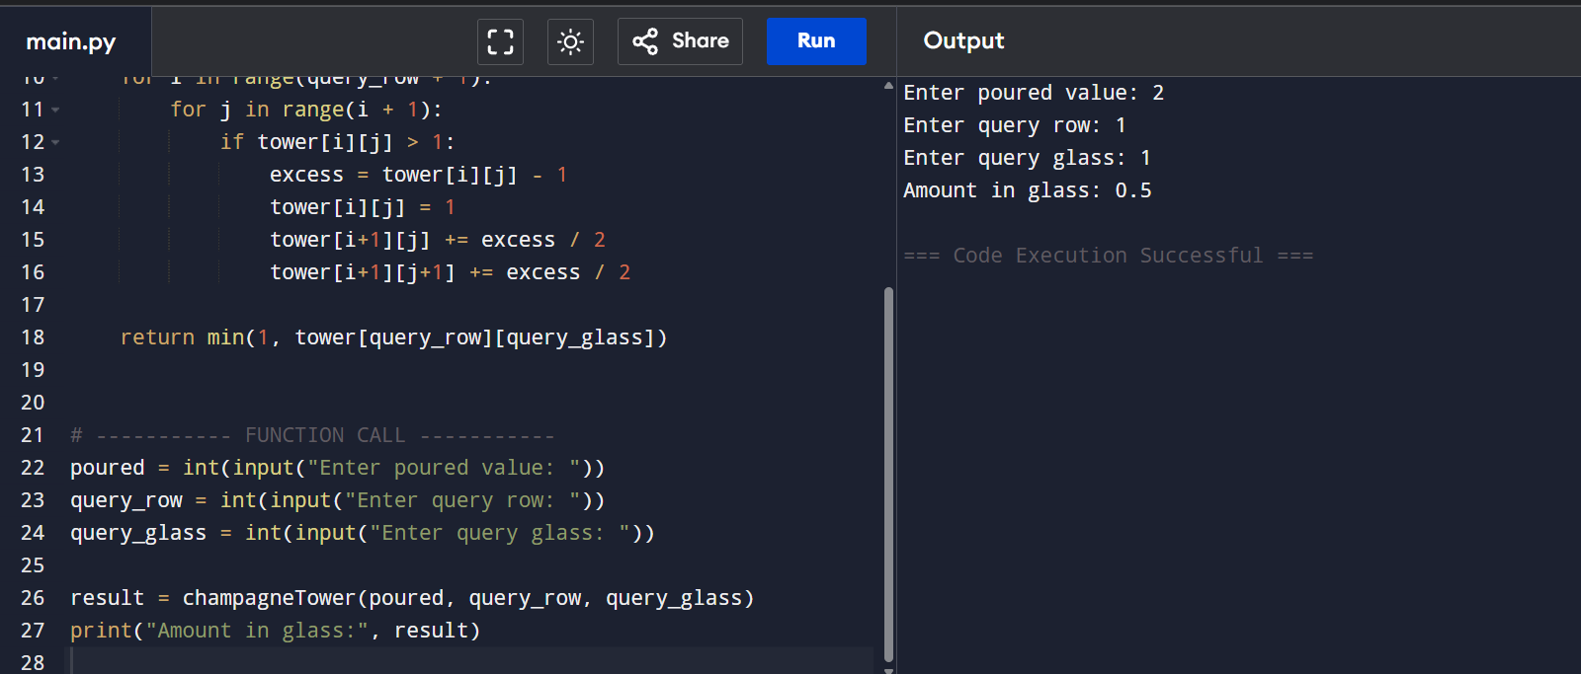

RESULT: The program correctly calculates how much champagne is contained in the specified glass after pouring.

